Recap NEWC Meeting, February 21, 2019

Introductions: Calvin College senior nursing students attended and participated in our discussions. We welcome them to join us any time! Thank you, Dr. Miller for including them.

Taking Stock of Where We Have Been and Where We Are Going:
- A little history;

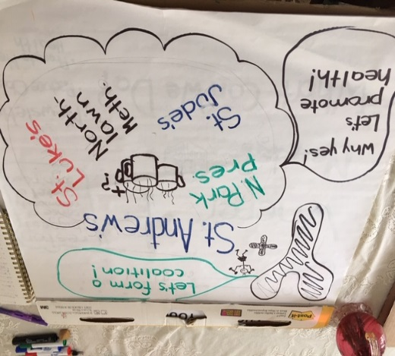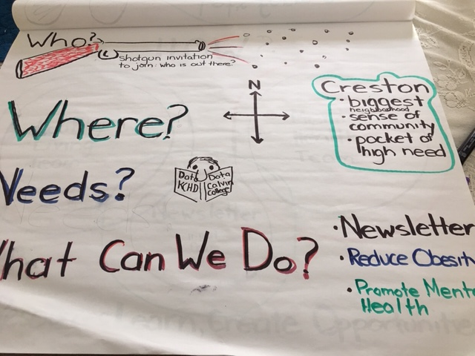
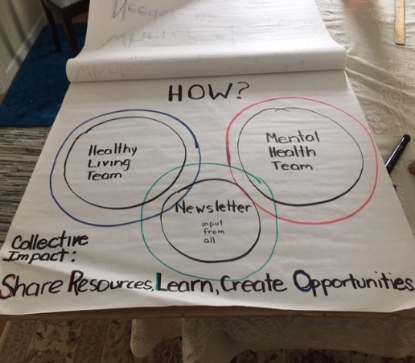
- Systems work refresher
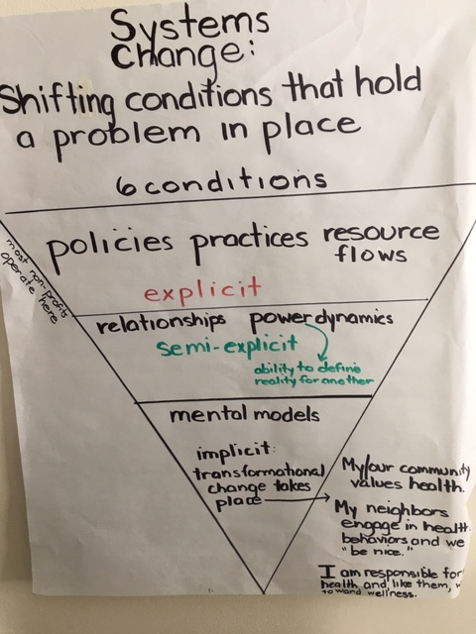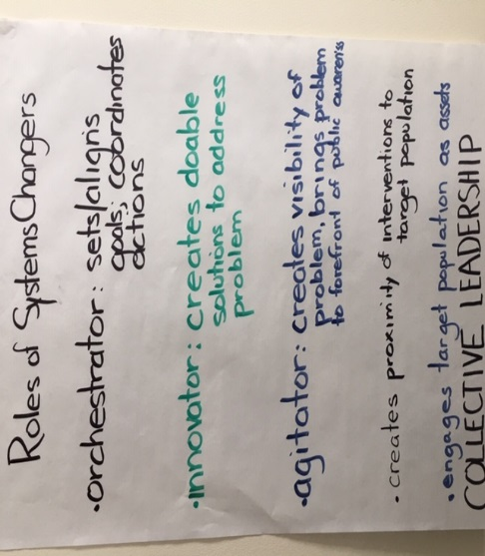

- Report out on status of our 2 work groups’ projects:
What have we accomplished?
What are recent challenges?
What are recent successes?
What have we learned?
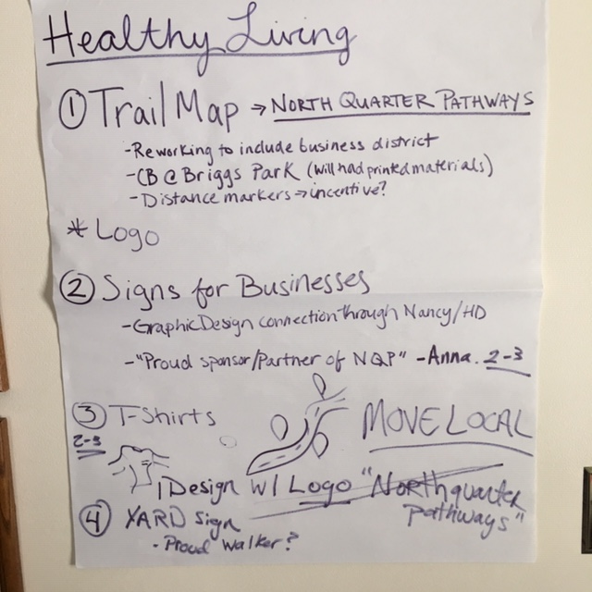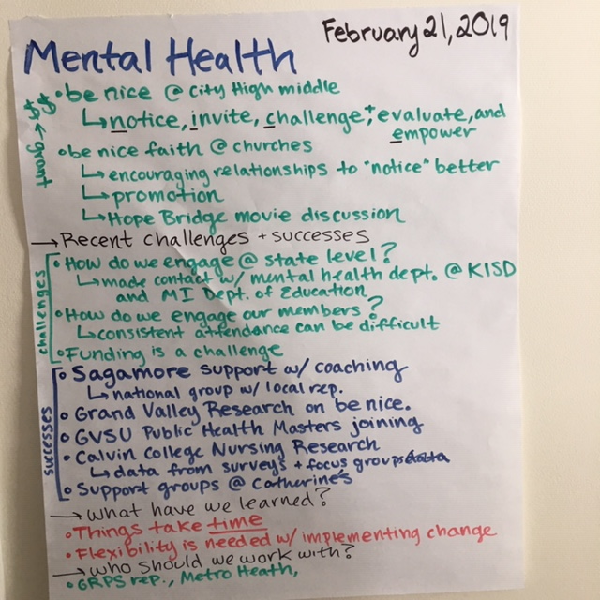

Report Out and Sharing:
Nancy Brubaker reported on the Healthy Vending Machine project at Mercy Health. Perhaps this would be a good project to learn about relative to NEWC efforts, as well as a way to engage Mercy Health with our group.

Next meeting: March 21, 2019, 9:30-10:45 a.m.; 205 Carrier St. NE

