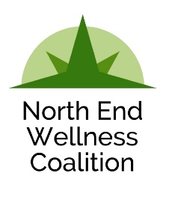
Meeting Agenda
March 21, 2019
9:30-10:45 a.m.
205 Carrier Street NE

Introductions / Wellness Warm-up (5 min)

How ARE we doing? (20 min)
- Is NEWC measuring up to your needs and expectations?
  - What brings you here?
  - What are you gaining? What would you like to gain?
  - How do your organization’s strengths and your own personal talents lend themselves to this community health promotion?
  - What strategies are there for flexible/added involvement?
- (Time permitting) What can we measure to ascertain efficacy (engagement vs influence)?
  - Newsletter

Work Groups (40 min)
- Healthy Behavior Team: Next step strategies
- Mental Health Team: Next step strategies

Report Out and Sharing (10 min)
Notes:

Next meeting: April 18, 2019 at 9:30 - 10:45 AM

