Recap NEWC Meeting, March 21, 2019

- We welcomed Aisha Brown, community care worker, and Karen Niemchick to the table this month.
- Tom Page thankfully returned to our group after several months of being assigned to a parish out of our area.
- We took time to assess how we are meeting the needs of our membership. Discussion followed with the most energy given to the desire to collaborate with fellow members outside the confines of the NEWC meeting. To that end we are producing a directory of our members and their contact information.
Members expressed interest in getting updates mid-month as well as meeting in small groups between meetings to accomplish targeted work.
Additionally members asked for more personal contact. We need to flesh out with the group what this means.

What brings you here?
Reconnection; awareness of who is at the table
Service to the community through mental health education
Investment in the health of the neighborhood
Friends and family in the neighborhood

What are you gaining?  Knowledge/ resources  Existing agencies  Ability to break down silos  Networking so we know who is doing what/  where/ and to whom | What do you hope to gain?  Information/partnership  Community development  Blue Zone GR  Resources on Mental Health  Shared purpose  Interfaith connection  More personal contact  More contact between meetings  More follow-up between meetings
Organization’s Strengths  Competence for addressing target areas  Connected to the communities’ needs  Availability for support  Outreach  Historical knowledge and connections  Mission statement | Personal Strengths  Patience  Cross sector participation  Leadership  Open mindedness  Love of service  Personalities

Work Group Accomplishments:
Healthy Living
The trail group reviewed progress on the fundraising action items; Elianna will forward window cling images to Kamara for use in the updated trifold, which is intended to be completed by the end of the month. The group raised the idea of geocaching (scavenger hunt with GPS). Elianna collected feedback on the route and window clings; we will aim towards a small one for “partners” and a large one with map for “sponsors”. We noted the font for the “Pathways” will be updated to the same as the “North Quarter” (we have approval from the CID to use their name/brand pending concurrence from the legal department regarding liability). We liked the small one with the trail clip art. Nancy confirmed that the Health Department will make our loops available as part of their walking outreach materials; she will follow up to find out if there is an app as well. Trish shared potential t-shirt designs. We concluded that North Quarter with an outline of the route will go on the front, NEWC’s full name and logo will go on the sleeve, and Move Local and the NEWC website will go on the back. Elianna shared her online survey results about the logo – 7% of the 85 words mentioned were marijuana, brought up by 12% of the 57 respondents. Many of the people mentioning it also directly noted that they were in states where marijuana was legal. However, more frequent words brought up were compass, sun/rise/set, nature/wilderness/outdoors, and plant. We concluded that we should always include the name when the logo is used.

Mental Health: The “be nice.” program at City High continues to march ahead as reported by Cat Lanting. We are missing representation from the school previously supplied by the assistant principal. We have made contact with the principal, Ryan Hubbert, and will request a replacement and possibly student representation.

The Mental Health foundation of West Michigan enjoyed fabulous response to be nice. faith institutes. They are following up with webinars and a plethora of individual course offerings to further participants knowledge and capability in addressing mental health issue. Additionally MHF is meeting with representatives of the Episcopal Diocese of West Michigan to explore the possibility of bringing the institute to a number of churches within the diocese.

NEWC will work to compile an address list of churches within the Creston and Belknap neighborhoods for MHF use in targeting the area for future institutes and follow-up training.

MHF’s annual fund raiser: Stomp Out Stigma is scheduled for May 18. We would like to have a NEWC table at the event but will need to come up with some level of funding. We will work to put a team together to participate at April’s NEWC meeting.
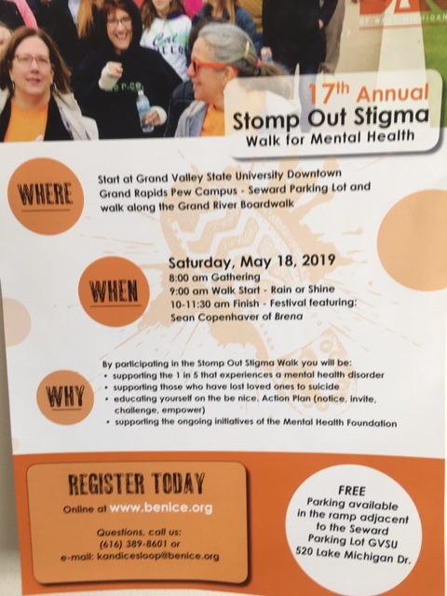

Members shared:
1. Trish: Conversation with Living Green, we will follow up for more info
2. Nancy: Walk for Good Food, May 21; posters to follow

